SHARIFAH ZUBAIDAH BINTI SYED MAZLAN
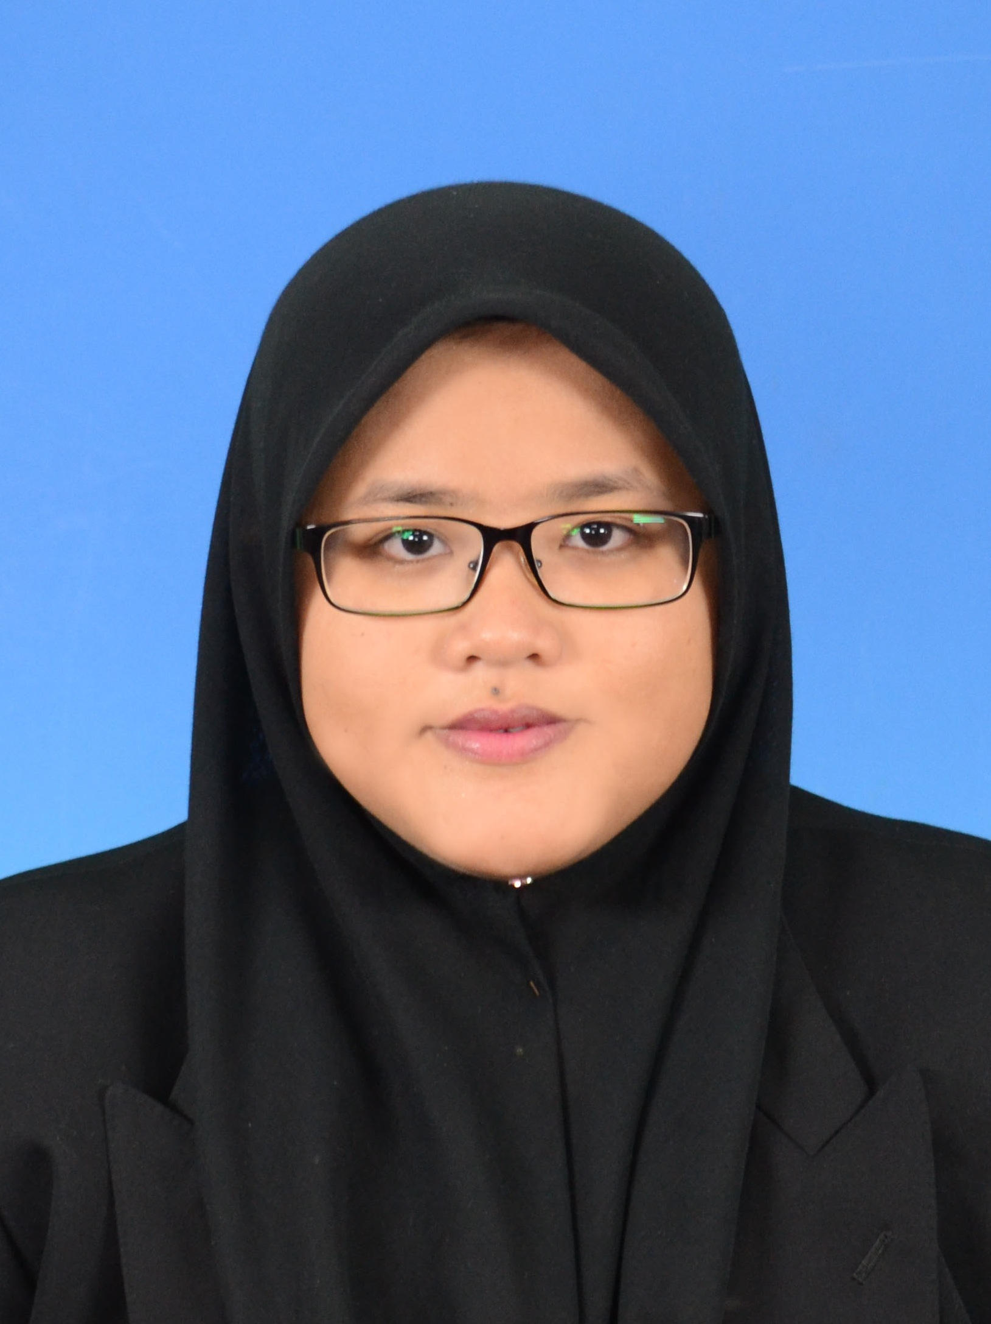
013-7609753
sharifahzubaidah06@gmail.com
164 Kampung Gong Kapas, 21100 Kuala Terengganu,
Terengganu Darul Iman.

CAREER OBJECTIVES

- To contribute my countless skills and knowledge to the company and gain more experiences for my future.
- To give my full commitment in my job and to be success in my career life.
- Able to work in long hours and willing to travel.

EDUCATION AND QUALIFICATIONS

Universiti Malaysia Pahang
Bachelor of Engineering (Hons), Mechanical Engineering (2011-2015)
Second class degree (lower).

Kolej MARA Kulim (Matrikulasi)
Class of Science Physics (2010-2011)

Sekolah Menengah Agama Khairiah,Terengganu
Sijil Pelajaran Malaysia (2009)

EXPERIENCES

- Staff at A&W Batu Burok Kuala Terengganu (2011)
- Part-time Aidijuma staff at UMP Expoconvo (2013)
- Internship position at Empire Scope Sdn Bhd at Cheras, Kuala Lumpur.
: 30th June -5th Sept 2014 (2 months 2 weeks)
: As one of the maintenance team.
: Went to site around Selangor (Pusat Internet 1 Malaysia)
: Learned the procedure of the installation of the equipment regarding Mechanical and Electrical works.
- Final Year Project - Experimental study on corrosion rate of 316-stainless steel.
: Determine the rate of corrosion of the 316-SS with temperature effect with constant PH-value using Weight Loss Analysis (WLA).
: Investigate the factor affecting the rate of corrosion.
- Oil & Gas CAD Enhancement Program for Oil & Gas / Engineering Sector. : 5th Oct- 28th Nov 2015 at UniMY Putrajaya.
: Fully supported by GEMS Malaysia Sdn Bhd and conducted by Prestariang Systems Sdn Bhd.
: Programs including Professional skill set for Oil & Gas industry, Proficiency in Enterprise Communication (PEC), Autodesk AutoCAD, Inventor and 3D plant/piping courses.

ADDITIONAL INFORMATION

Extra curricular
  - EXCO of Mechanical Festival (MechaFest) UMP 2014
  - Participated in CIDB green card course (2014)
  - EXCO of MECHAPRO (Secretariat)
  - Member of PEKA 5 (2013/2014)
  - EXCO Le Tour KARISMA UMP De Pekan ‘Pahang’ (2012)
  - EXCO Initiative For Cancer Awareness: Cervical Cancer (ICARE 2012)
  - Member of Festival Hari Hutan Antarabangsa Peringkat Kebangsaan (2013)
  - Participated in Bengkel Pengurusan Kewangan (2013)

Personal Characteristics
  - I am a highly motivated person where the punctuality and hardworking is my priority.
  - I am also able to work under pressure and highly desire to upgrade the knowledge and skills.

Languages
- Fluent in conversational Malay and English.
- Arabic in intermediate.

Computing
- Skilled in using the computer application including Microsoft Office.
- Skilled in designing software including Autodesk Simulation, AutoCAD, Inventor and Autodesk 3D Plant.
- Familiar and good in managing and handling the programming software including DASY-lab with NI-DAQ hardware, Code Blocks and Math Lab.
- Skilled and have basic in handling mechanical machines including Grinding, Milling and Drilling.
- Have AutoCAD and Inventor 2015 certificates.
Leisure
- Interested and experienced in Kayak and rafting activity.

REFERENCES

Dr. Fadhlur Rahman Bin Mohd Romlay Lecturer and Personal Advisor
Faculty of Mechanical Engineering
UNIVERSITI MALAYSIA PAHANG
TEL : 09-5492688 `
FAKS: 09-5492689
Mr. Lee Giok Chui SMP. KMN
Final Year Project Supervisor
Faculty of Mechanical Engineering
UNIVERSITI MALAYSIA PAHANG
TEL : +6012-9087821

